|  |  |
| --- | --- |
| NAME | V.VISWA |
| NM ID | 7C3A62FE3E5842DACD04D307E4D53B68 |
| COLLEGE NAME | SARANATHAN COLLEGE OF ENGINEERING |
| PROJECT TITLE | CREATING AN SPONSORED POST FOR INSTAGRAM |
| CATEGORY | DIGITAL MARKETING |
| DEPARTMENT | ELECTRONICS AND COMMUNICATION ENGINEERING |

Brand Email : [ramachandra.sweet.stall@gmail.com](mailto:ramachandra.sweet.stall@gmail.com) /Password : R.Selvarani

Facebook business Page :

<https://www.facebook.com/ramachandrasweetstall>

**Documentation:**

**Navigation:**

[https://www.canva.com/](http://www.canva.com/)

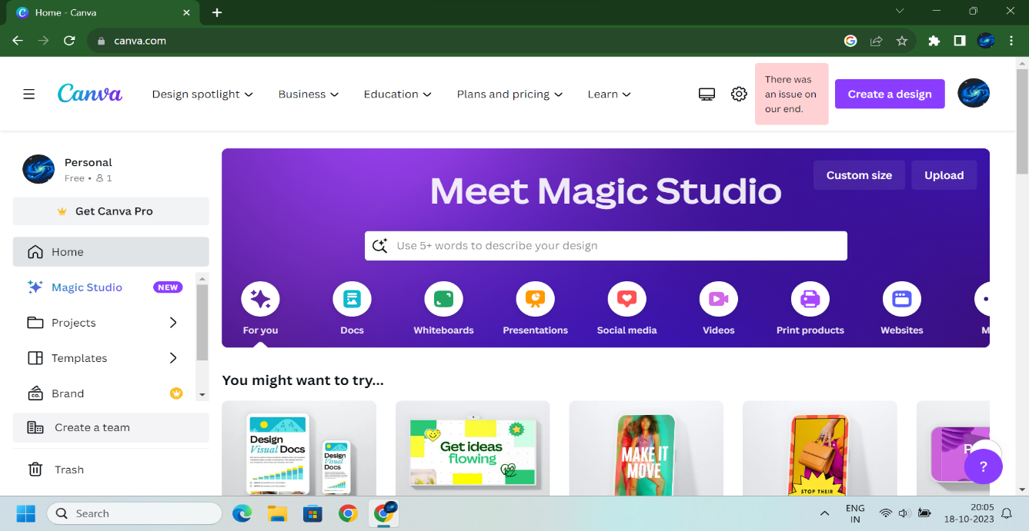

**Choose Format And Design :**

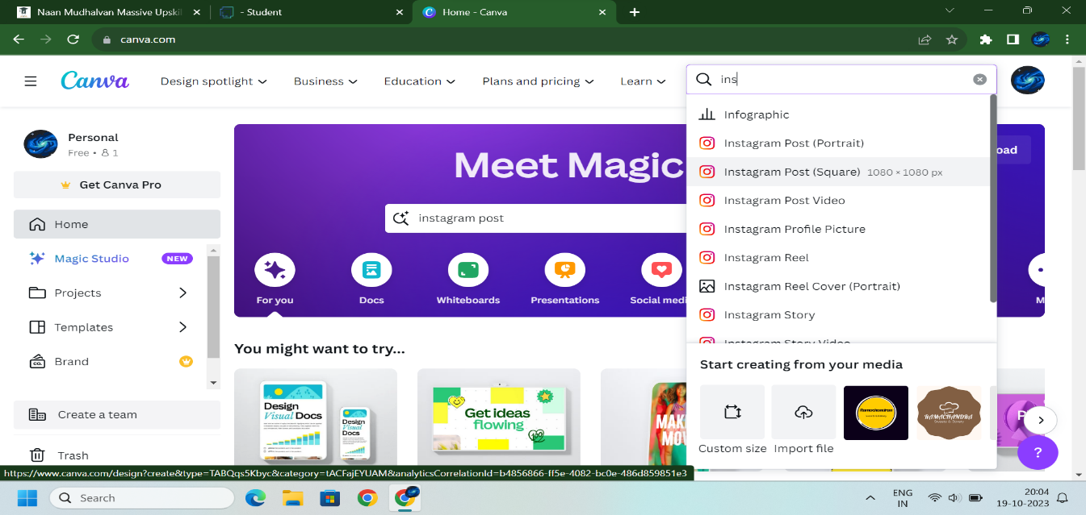

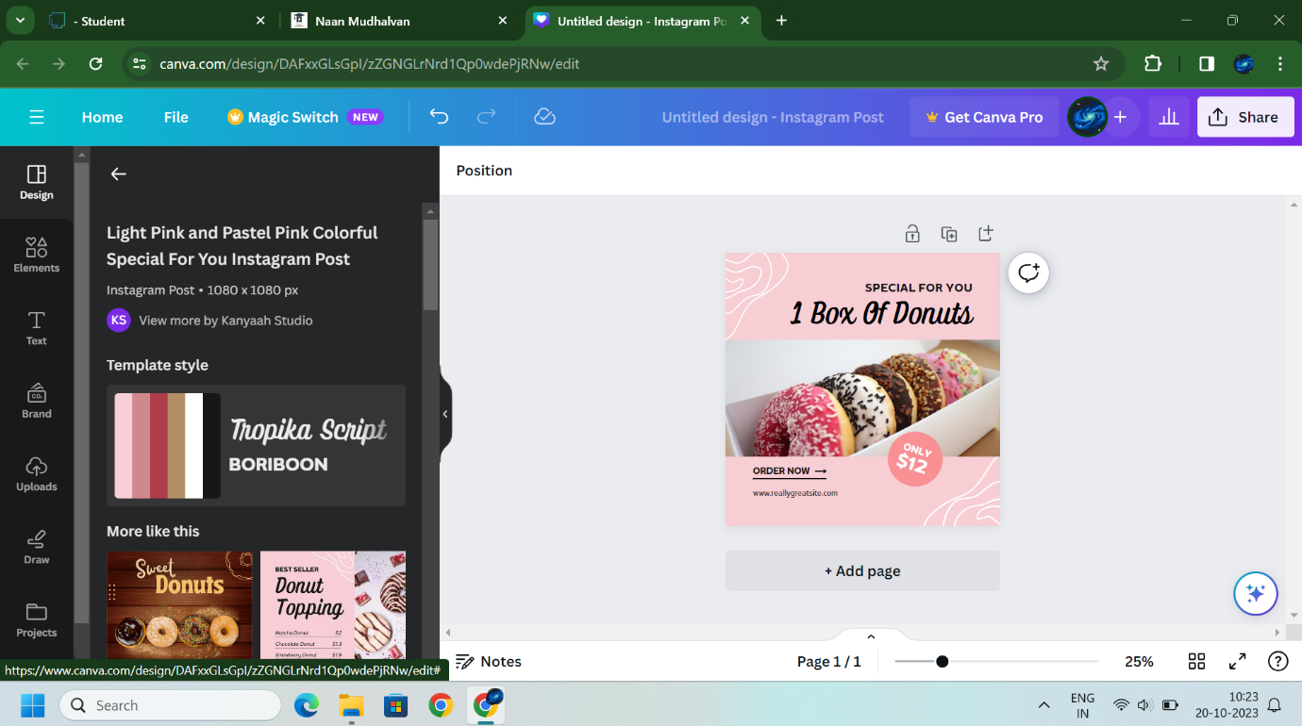

**Upload Logo and Resize :**

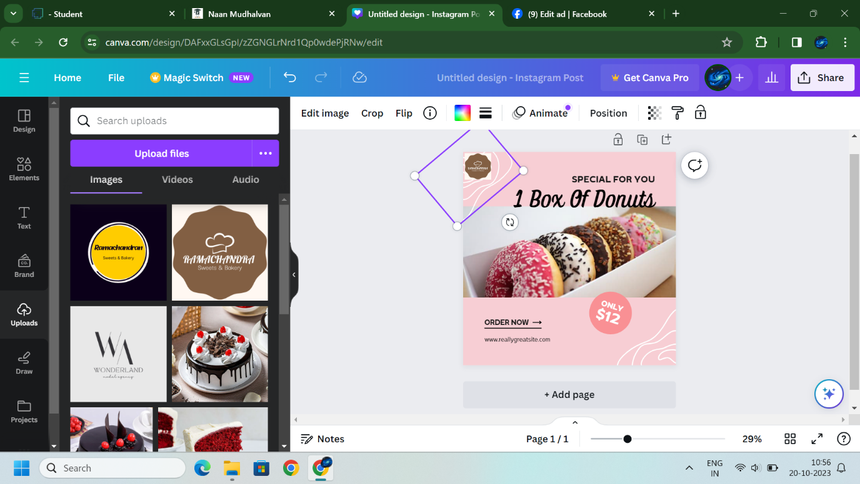

**Download the post PNG format:**

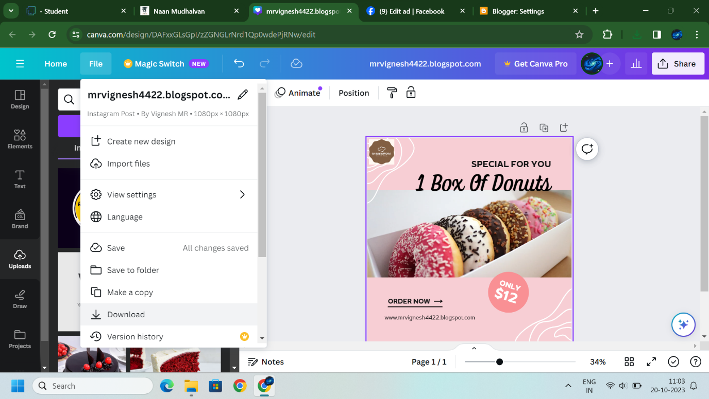

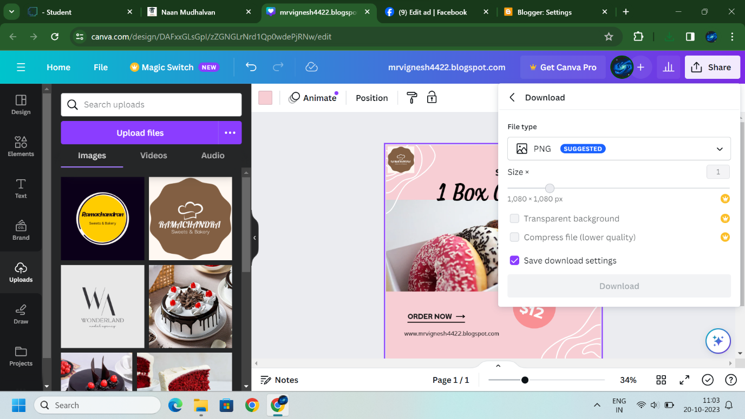

**Goto Facebook:**

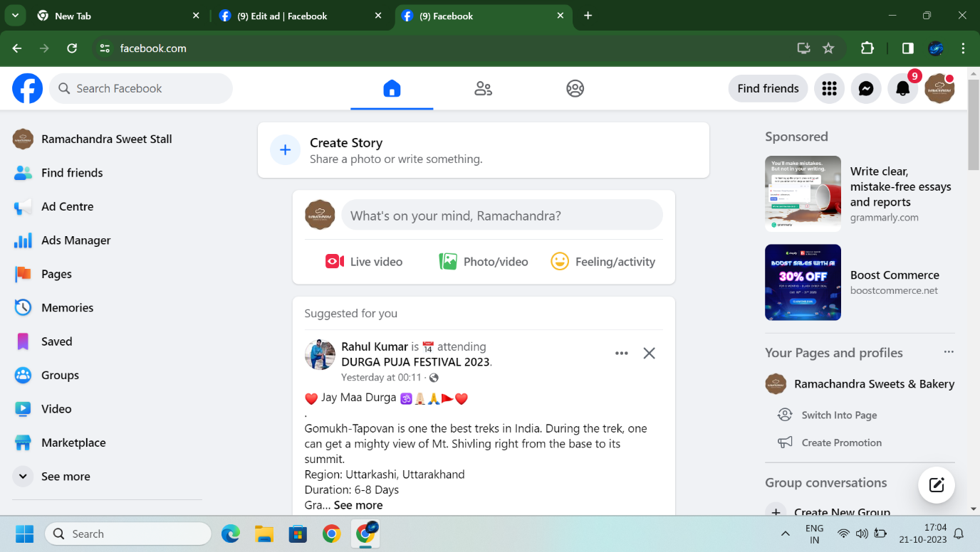

**Click Ad:**

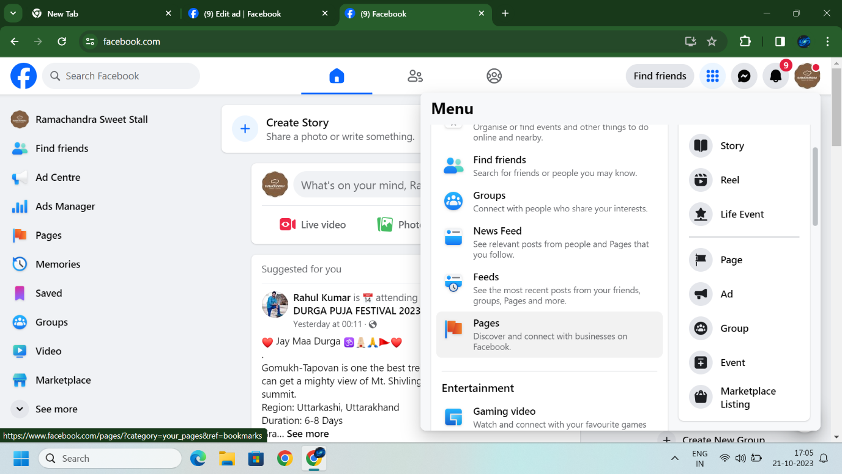

**Create New Ad:**

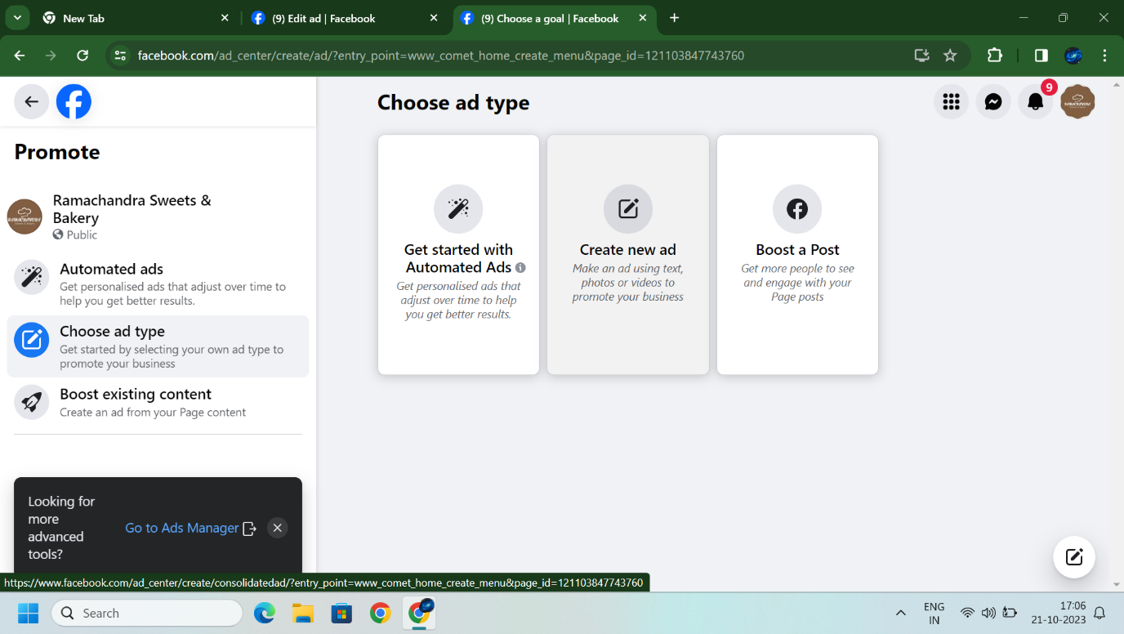

**Description about your brand :**

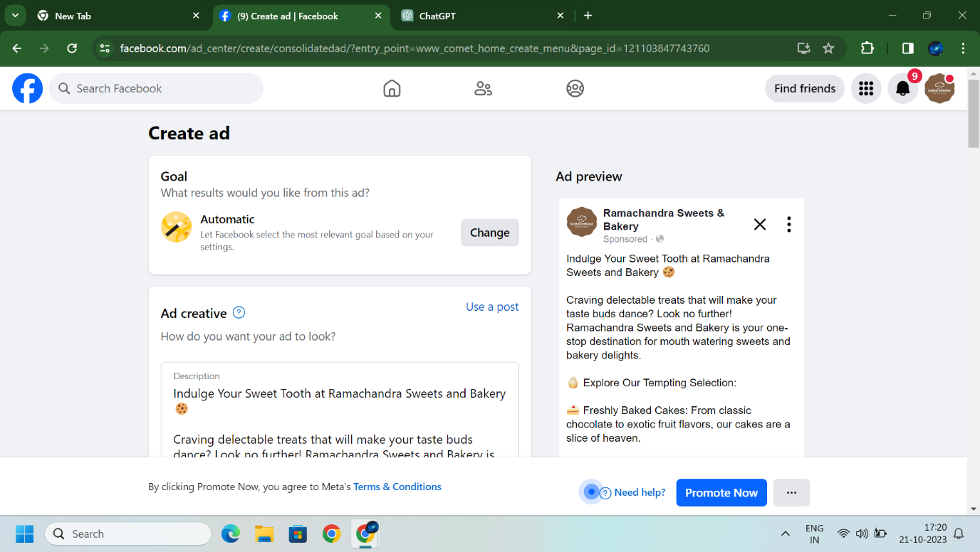

**Mention your website and Mobile number:**

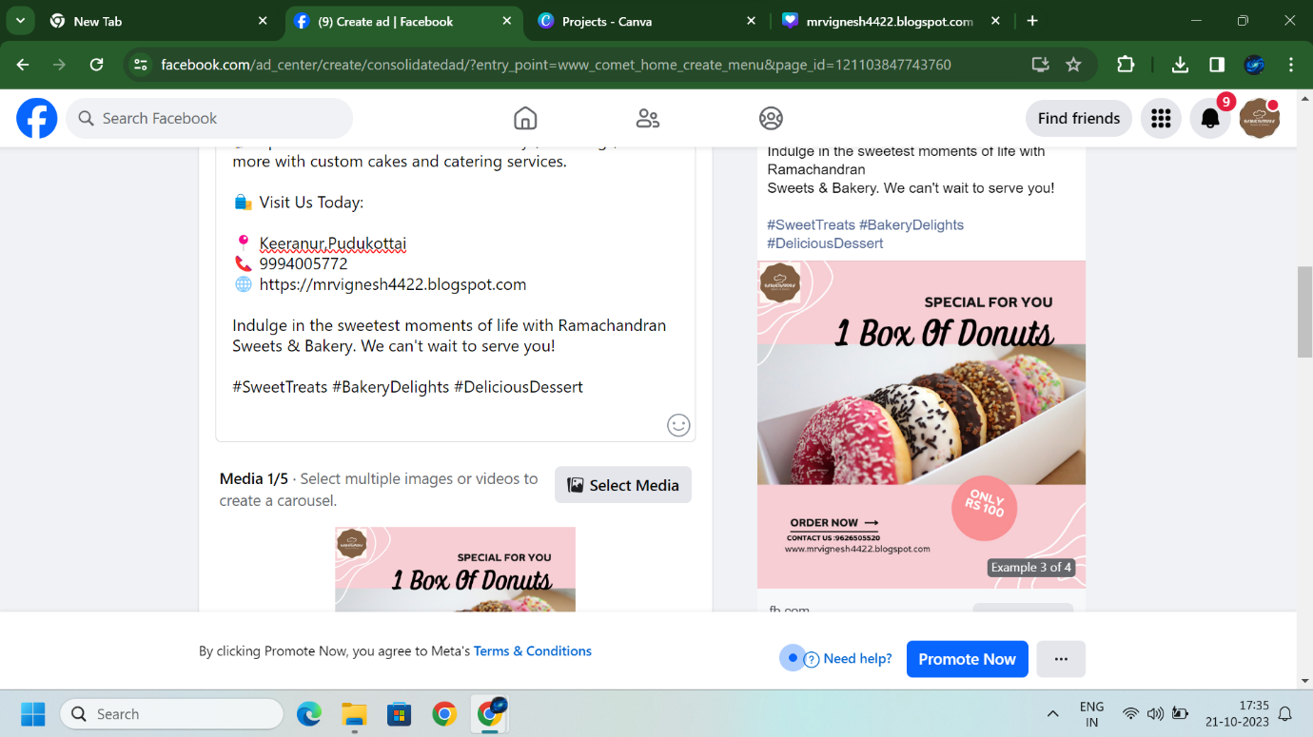

**Upload post:**

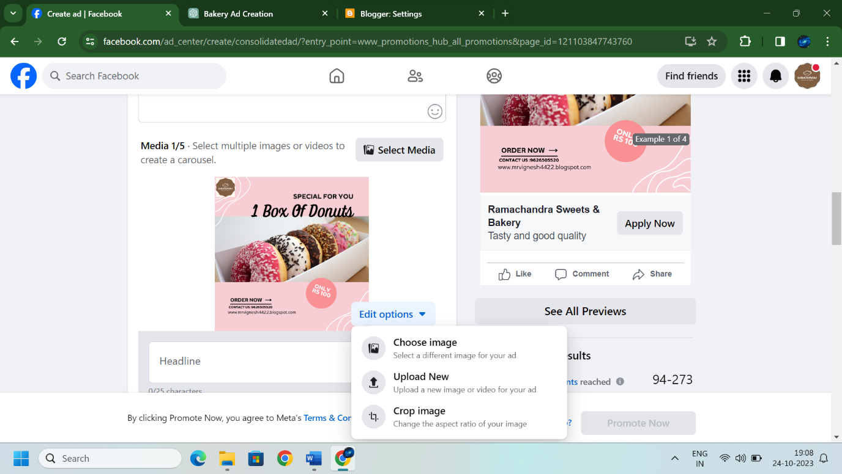

**Schedule and Duration:**

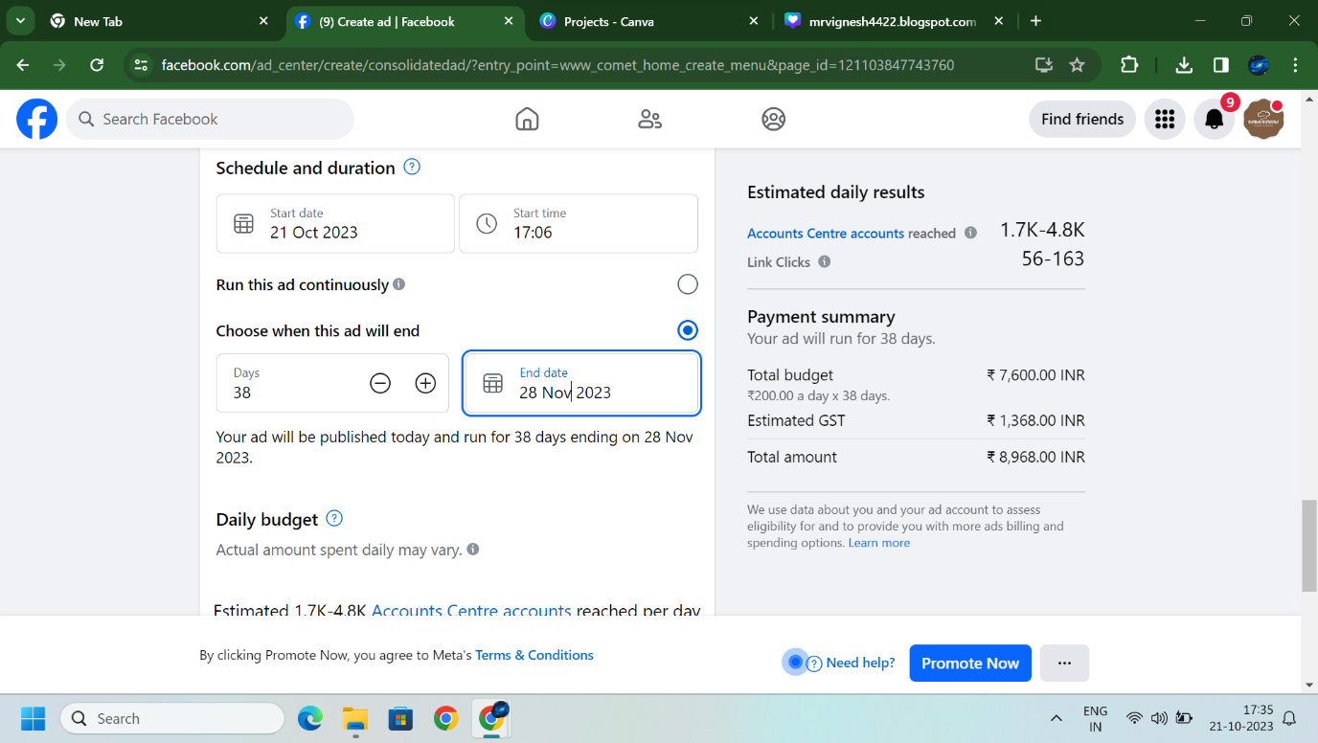

**Instagram post Review:**

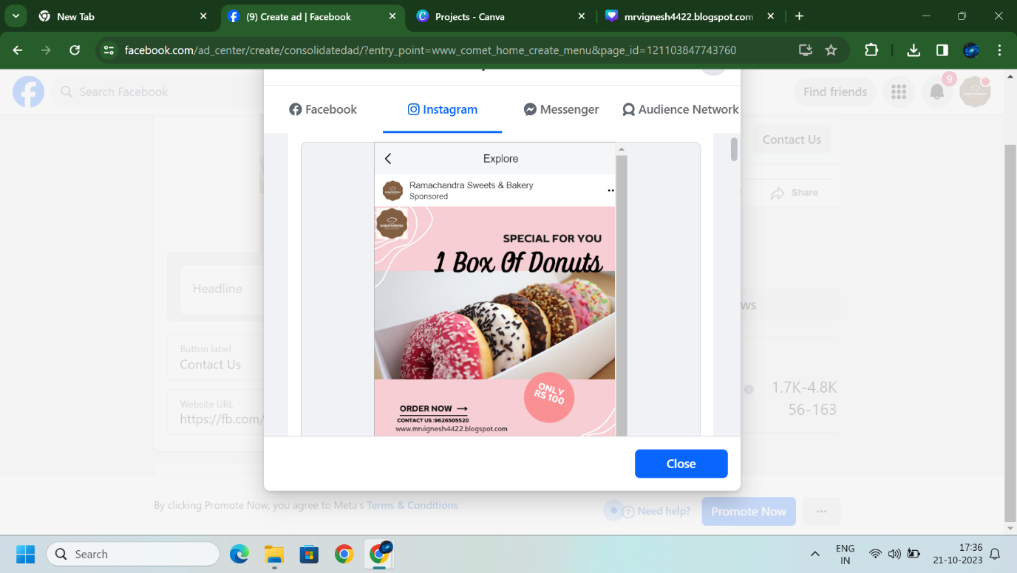

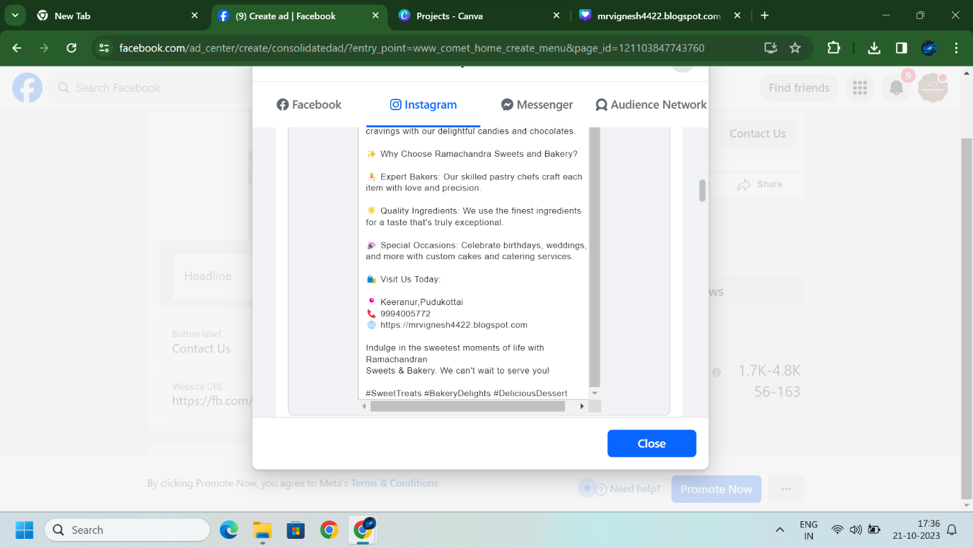

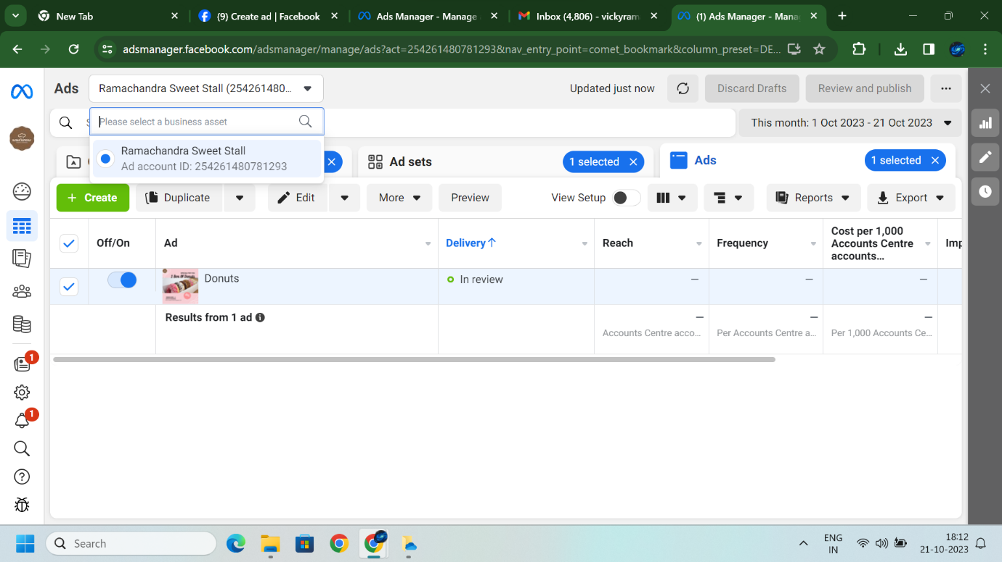

**Sponsored Instagram post:**

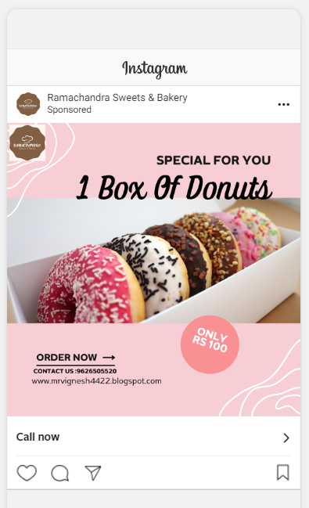

**Demo Link :**

<https://youtube.com/shorts/09rcRxhmaek?si=G1ke2blCHWrSQP7S>